**Family and Friends 1 – Unit 2**

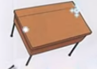

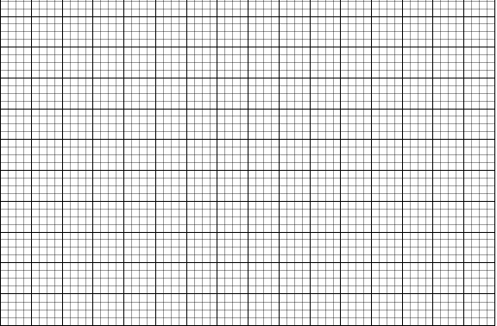

table

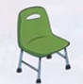

chair



crayon

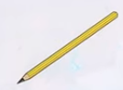

pencil



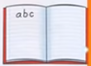

notebook

1. Look and match.



1. It’s a notebook.



2. It’s a crayon.

3. It’s a chair.





4. It’s a pencil.



5. It’s a table.

1. Look and write.



**III. Look and answer the questions**.

1. What’s this?

It’s a _________________.

1. What’s this?

It’s ____ _______________________.

1. What’s this?

It____ ____ ____________.

1. What’s this?

It____ ____ ____________.

1. What’s this?

____ ____ ____ ____________.

p e n c i l

__ __ __ __ __

__ __ __ __ __

__ __ __ __ __ __ __ __

__ __ __ __ __ __

